[SE Name]
[SE Email]
OP# [Number]
[Date]
WFM solution design
[Customer Name]

Contents
Introduction 4
Project Summary 4
Workforce Management - WFM 5
WFM New deployment Information 5
WFM Upgrade/Migration Information 5
WFM Staging New Deployment Information 6
WFM Authentication Method 6
WFM Environment and ACD Details 7
WFM NICE Connectors 8
WFM SmartSync 8
Employee Engagement Manager – EEM 9
EEM Authentication Methods 9
Appendix A - WFM 10
NICE Datacenter Connection Type 10
High Availability 10
Disaster Recovery 11
WFM Disaster Recovery for all customers (Available Globally) 11
RPO = 24 hours (for all customers) 11
RTO: Available Disaster Recovery options: 11
Cloud Services High Availability 12
WFM Architecture 13
Appendix B - EEM 14
EEM Architecture 14

Revision History
Revision | Person(s) | Date | Notes
[Version ] | [SE Name ] | [Date]

Introduction
This document describes the connectivity and configurations necessary to implement the NICE WFM solution in our Cloud environment. In the Cloud environment NICE carries the responsibility for the following:
- Infrastructure and Configuration Administration
- Performance Tuning
- Infrastructure and Application Services Monitoring and Capacity Management
- ACD Integration and Services Deployment
- Application Support (including patches, updates) and Availability Reporting
- Physical and Procedural Security based on SSAE 16 SOC 2 compliance.
- High Availability, infrastructure resiliency and redundancy
- Backup and recovery of data
- Georedundant Disaster Recovery (if purchased)
This document will serve as a tool for continuity as the project is commenced. It is meant to serve as a road map for deployment to meet both the architectural requirements and business initiative needs that were discussed during the sales phase of the project.
Also note that this document was prepared pre-project, and as such, configuration and deployment methods should be reviewed by the assigned project team to address any specific environmental needs and learned/latest best practices.

Project Summary
[Project Summary]

Workforce Management - WFM

[WFM New deployment Information] [[If it’s a New Business then this section is included otherwise removed]]
[Licensed Agents]
[Number of WFM Production system installations (tenant info on the ACD details section)]
[WFM Environment/Tenant Type] | Choose an item.
[Employee Engagement Manager] | Choose an item.
[AI Forecasting] | Choose an item.
[Enhanced Strategic Planner] | Choose an item.
[GDPR Compliance] | Choose an item.
[HR Direct Integration] | Choose an item.
[Cloud Reporting] | Choose an item.
[Disaster Recovery ] | Choose an item.
[Staging Environment (Required above 20k agents)] | Choose an item.

[WFM Upgrade/Migration Information ] [[If it’s a migration then this section is included otherwise removed]]
[Upgrade type] |  | Choose an item.
[WFM Cloud Deployment] |  | Choose an item.
[Existing WFM Version] |  | Choose an item.
[Existing DB Operating System] |  | Choose an item.
[Existing Database] |  | Choose an item.
[Number of WFM PROD system installations (tenant info on the ACD details section)]
[Staging Environment |  | Choose an item.
[New WFM version Authentication method] |  | Choose an item.
[Enhanced Strategic Planner] |  | Choose an item.
[Employee Engagement Manager] |  | Choose an item.
[AI Forecasting] |  | Choose an item.
[HR Direct Integration] |  | Choose an item.
[Cloud Reporting] |  | Choose an item.
Disaster Recovery ] |  | Choose an item.
GDPR Compliance] |  | Choose an item.

[WFM Staging New Deployment Information]
[Number of WFM system installations (tenant info on the ACD details section)] | 1
[Environment/Tenant Type] | Choose an item.
[Licensed Agents ] | 200

*Frequency of restoring or copying a production database in a lab/stage environment is limited to a few times annually and requires the customer to initiate a service ticket.

Additional Information:

[WFM Authentication Method]
[WFM Authentication ] | Choose an item.
[EEM Authentication] | Choose an item.
[NDE Authentication] | Choose an item.
[Staging Authentication] | Choose an item.

NOTE – REMOVE PRIOR TO PUBLISHING

SSO Considerations:
- 1:1 Relationship between WFM Tenant to SSO IDP. Should the customer have multiple SSO Identity Providers (IDP), a separate WFM tenant would be required per account.

- 1:1 Relationship between NDE to SSO IDP. Should the customer have multiple SSO Identity Providers (IDP), a separate NDE deployment would be required per account.

- Specific for Employee Engagement Manager (EEM): While EEM can support a 1 to many relationships with IEX tenants (and environments); should the customer have more than 1 SSO IDP, a separate EEM environment will need to be deployed in support of each.

WFM Environment and ACD Details
 | Number of Tenants
Production | [Number of Tenants]
Staging | [Number of Stage Tenants]

Note: In the event there is a 3rd Party Vendor Requirement, reports will be required from the vendor. Customer is responsible for associated costs from the 3rd party vendor for their portion of the integration. Integration Intervals must match within the same WFM system.

Environment | Tenant No. | ACD Information (Vendor) | ACD Model/Version | ACD Interval | ACS Required (Y/N) | 3rd Party Vendor Requirement
 |  |  |  |  |  | ☐
 |  |  |  |  |  | ☐
 |  |  |  |  |  | ☐
 |  |  |  |  |  | ☐
 |  |  |  |  |  | ☐

**If the third-party vendor requirement is checked the customer is required to contact the third party to purchase the integration adapter.
Additional Information:

NOTE – REMOVE PRIOR TO PUBLISHING
- Insert appropriate and relevant information for each ACD from the latest NICE IDD
- Validate that the ACD Make/Model/Version is supported in the IDD – if not, put the integration in the SmartSync section.
- If environment is receiving data from Desktop Analytics – ASCWS will be required

WFM NICE Connectors
NICE Interactions Management / NICE Engage Platform  (NOTE: SmartCenter integration with WFM V8 requires LDAP authentication to be enabled) | Choose an item.
[NICE Performance Manager (NPM)] | Choose an item.
[CXone Performance Manager] | Choose an item.
[Desktop Analytics Web Services Protocol (DPA)] | Choose an item.
[NICE EEM] | Choose an item.

WFM SmartSync
[Add New SmartSync Import or Export] | ☐
[Upgrade Existing SmartSync Connections] | ☐

Smart Sync | Intended Use | Tenant | Type
Choose an item. |  |  | Choose an item.
Choose an item. |  |  | Choose an item.
Choose an item. |  |  | Choose an item.
Choose an item. |  |  | Choose an item.
Choose an item. |  |  | Choose an item.
Choose an item. |  |  | Choose an item.
Choose an item. |  |  | Choose an item.
Choose an item. |  |  | Choose an item.
Choose an item. |  |  | Choose an item.
Choose an item. |  |  | Choose an item.

Additional Information:

Employee Engagement Manager – EEM

[Total Number of EEM Agents]
[Number of WFM instances (Systems):]
[WFM Version:]
[Number of Tenants per instance:]
[Real Time Alerting] | ☐
[AI Insights] | ☐

EEM Authentication Method
[EEM Authentication] | Choose an item.

Additional Information:

Appendix A - WFM

NICE Datacenter Connection Type
WFM 8 supports the following default connectivity for the below components:
- Agent WebStation Portal: HTTPS
- WFM Supervisor workstation client application: HTTPS
- Historical ACD and SmartSync data transfer process: SFTP
- Real-Time Adherence ACD data via supported ACD integrations: HTTPS, IPSec B2B VPN

Any other requested connectivity can be discussed with relevant technical teams.

High Availability
The NICE Cloud Service infrastructure is designed to be robust and resilient from all aspects of the deployment in order to avoid single points of failure. The basis of this results in a high availability (HA) cloud service including the physical environment
The High Availability and redundancy for the production sites are built from 4 main elements:
- Tier III+ Data Centers:
  - Nice currently provides hosting services to its customers from its main production sites located around the globe. These services are deployed into data centers that possess the necessary technologies to achieve 99.9% uptime or better.
- Infrastructure N-1 deployment:
  - All production environments are designed for infrastructure for high availability, fault tolerance and scalability. NICE deploys each environment with redundant networks for avoiding single point of failure and for making sure that specific network failures will not have any impact on the environment.
- Technology:
  - NICE uses virtualization capabilities to provide additional resiliency and high availability that is being used for all of the environments, and protects from component failures, so in case there is a physical failure of a specific host, all VM’s that resides on this host are restarted automatically on another host.
  - Providing the monitoring capability to automatically optimize and fine tune for capacity management or transferred to an available host without any impact on the production system.
- Preservation Program:
  - The NICE Data Preservation program ensures that all customer data and full environmental VM images are preserved via a standard backup process that provide for validated backups.
  - Nice retains backups online to immediately respond to restore requests.
  - Backups are also stored safely and securely offsite.

Disaster Recovery
While the robustness and resiliency of the NICE Cloud Service infrastructure, deployment architecture and monitoring services provide for a high availability of service, NICE must plan for a disaster event whether natural or infrastructure related. NICE Cloud Operations maintains a Disaster Recovery Plan (DRP) designed to continue cloud services in the unlikely event of a major infrastructure failure or unavailability of facilities. NICE also maintains a Business Continuity Plan (BCP) that provides for the restoration and continuity of NICE’s operations.
NICE’s robust and resilient infrastructure combined with the data preservation program creates a low loss of availability risk scenario for most typical deployments of NICE cloud services. As a default NICE provides restoration of customers the default RPO above and a best effort recovery time objective (RTO).

WFM Disaster Recovery for all customers (Available Globally)
Disaster Recovery plays a role only in the unlikely event of a complete AWS region is down for a prolong period (days). In such case, NICE Cloud Ops team will use the last backup of the WFM database, to build the solution on newly provisioned infrastructure on alternative AWS region. (Such as US-East-1 to US-West-2, Ireland to Frankfurt, and Singapore to Sydney)

RPO = 24 hours (for all customers)
Since WFM backup is daily, this gives a Recovery Point Objective of 24 hours. In case of a disaster, the worst-case scenario would be losing 24 hours’ worth of data since the last backup.

RTO: Available Disaster Recovery options:

Option 1 – included for all customers free of charge: RTO = Best effort
For Customers that don’t purchase DR. NICE Cloud will standup a new environment on an alternative AWS region based on commercially reasonable best efforts.

Option 2 – Requires additional subscription fee: RTO = 96 hours
For Customers that purchase DR: NICE Cloud reserves AWS EC2 and RDS instances on alternative AWS region for a dedicated DR environment per customer. In case of a true disaster, the alternative AWS resources will be available to the Cloud Ops team for restoring the WFM platform using the last backup.
NICE Cloud tests the DR failover once annually. A copy of the report is shared with customers upon request.

Cloud Services High Availability
The NICE Cloud Service infrastructure is designed to be robust and resilient from all aspects of the deployment to avoid single points of failure. The basis of this results in a high availability (HA) cloud service including the physical environment, network connectivity and compute components. This HA capability provides the ability of the cloud service to recover from infrastructure or service disruptions dynamically.
The WFM solution is hosted on AWS, utilizing 2 AZ (Availability Zones), having HA across AZs on the component level. It is aligned with industry best practice having Three-Tier Architecture: Presentation tier, Application tier, Data tier. The WFM mandatory components are: Web Server, Application Server, and a DB Server. The WFM solution scales horizontally and vertically. The same architecture supports Single Tenant and Multitenant.
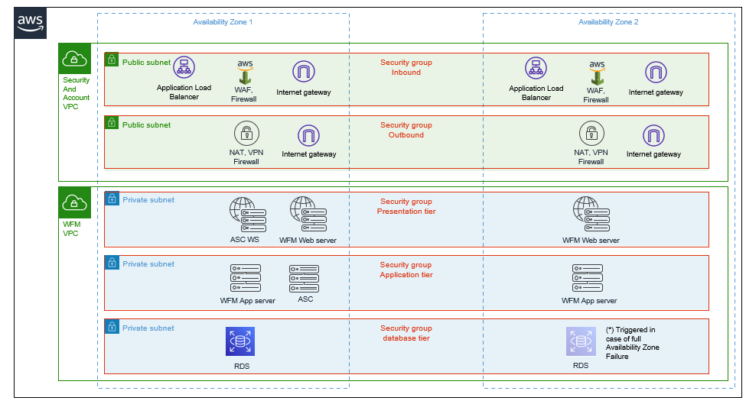

WFM Architecture
The logical architecture of the NICE Cloud application uses a three-tier model:
- The 1st layer of the application architecture is made up of networking switches, load balancers and intrusion detection systems. These perform a number of functions including URL translation or Universal Resource Identifiers (URIs) to internal IP addressing. Network based Intrusion Detection Systems reside on both sides of the load balancer.
- In the 2nd tier, the application servers are the termination point for all inbound requests. No requests from clients are allowed directly through to the database servers, all requests are terminated, appropriately escaped and then the application server builds required requests to the database server.
- The 3rd tier is represented by the database servers. Each database environment is a dedicated database storing a single set of database tables for that instance. If a customer has four instances of NICE Cloud, they will have four entirely separate databases, one unique to each instance.
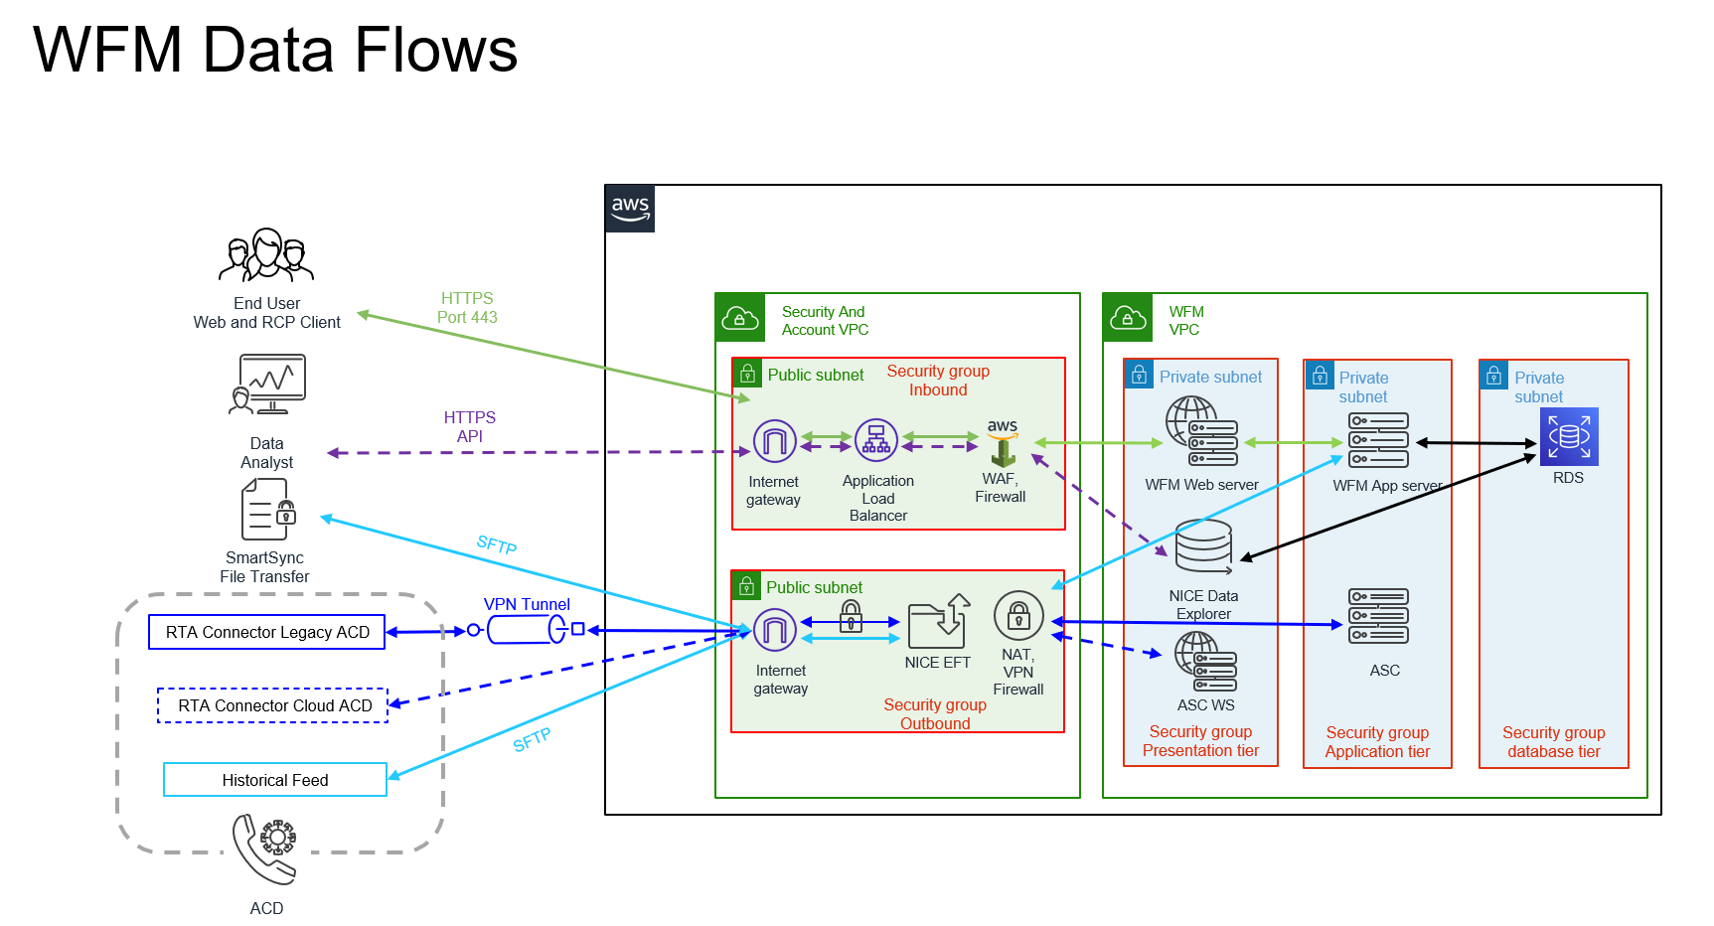

Appendix B - EEM

EEM Architecture

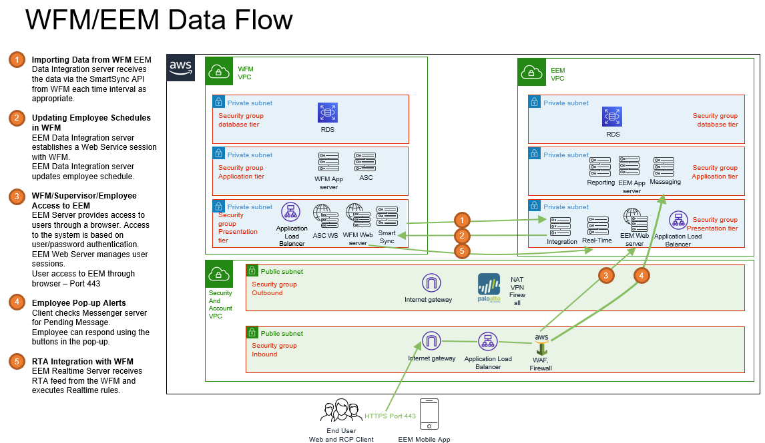

CONTACTS
Global International HQ, Israel, EMEA, Europe & Middle East,
T +972 9 775 3777, F +972 9 743 4282 T +44 0 1489 771 200, F +44 0 1489 771 665

Americas, North America, Asia Pacific, Singapore Office
T +1 201 964 2600, F +1 201 964 2610 T + 65 6222 5123, F +65 6222 5459

The full list of NICE marks are the trademarks or registered trademarks of Nice Systems Ltd. For the full list of NICE trademarks, visit www.nice.com/trademarks. All other marks used are the property of their respective proprietors.


CONTENTS OF THIS DOCUMENT ARE COPYRIGHT © 2025.
ABOUT NICE SYSTEMS INC.
NICE Systems Ltd. (NASDAQ: NICE) is the worldwide leader of software solutions that deliver strategic insights by capturing and analyzing mass quantities of structured and unstructured data in real time from multiple sources, including, phone calls, mobile apps, emails, chat, social media, and video. NICE solutions enable organizations to take the Next-Best-Action to improve customer experience and business results, ensure compliance, fight financial crime, and safeguard people and assets. NICE solutions are used by over 25,000 organizations in more than 150 countries, including over 80 of the Fortune 100 companies. www.nice.com.

